# Project Title:Employee-travel approval application for corporates

# 1.Introduction

# 1.1.Overview

# This project aim is to provide real-time knowledge for all the studentds who have basic knowledge of salesforce and looking for a real-time project.

# 1.2.Purpose

# Pre trip approval is to control undesirable travel buying behaviours of employee cost

# 2.Problem Definition & Design Thinking

# 2.1.Emphathy Map

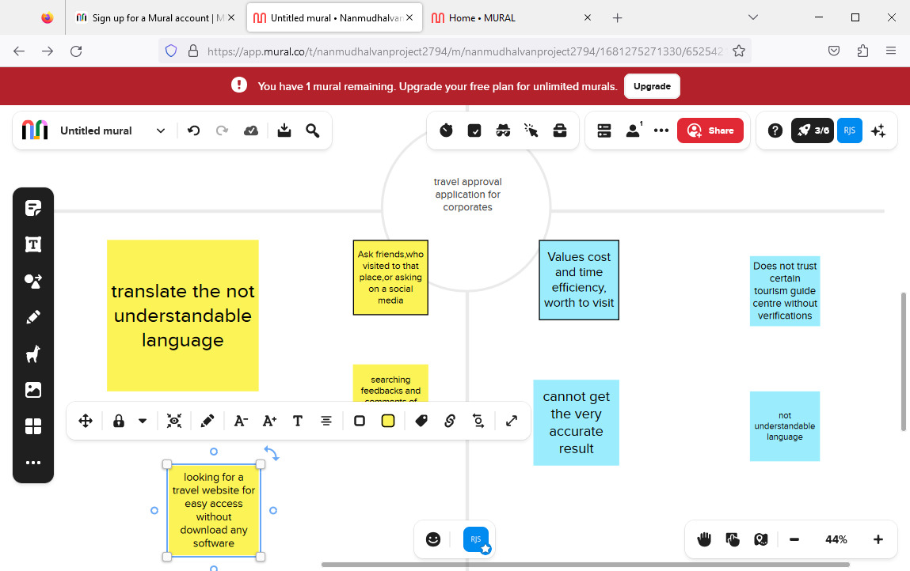

# 2.2.Ideation & Brainstroming Map

# 3.Result



# 

# 3.2.Activity & Screenshot

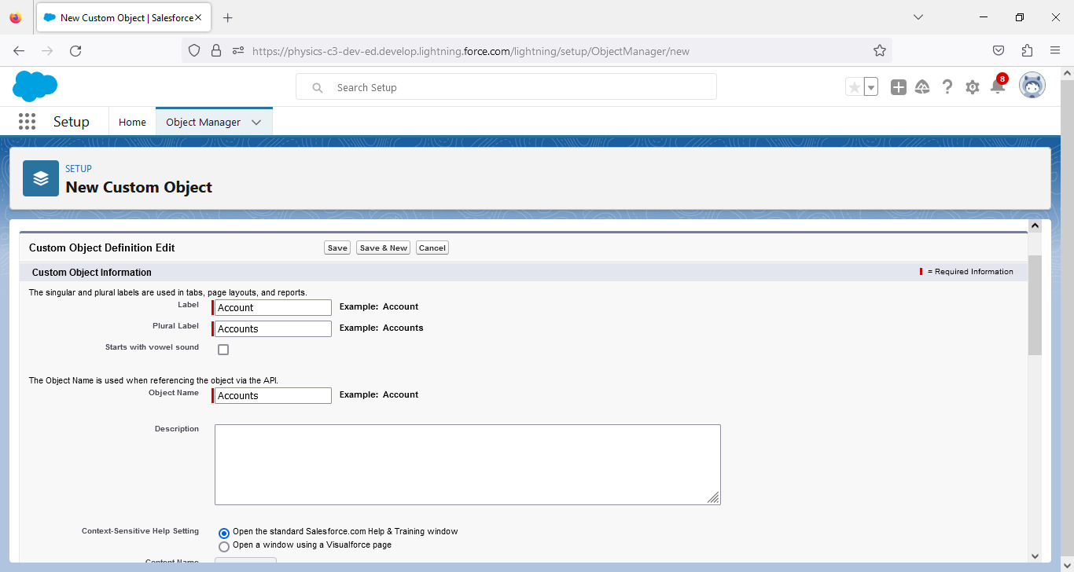

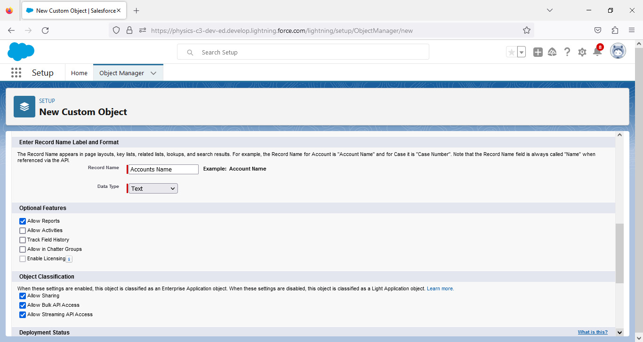

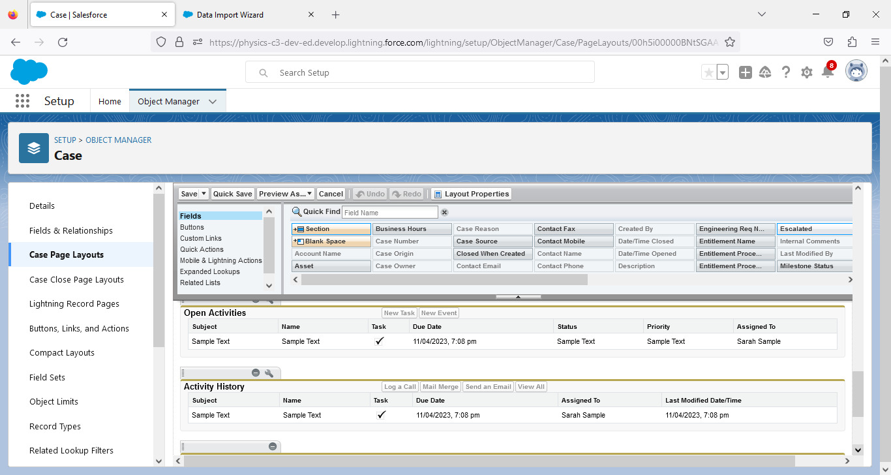

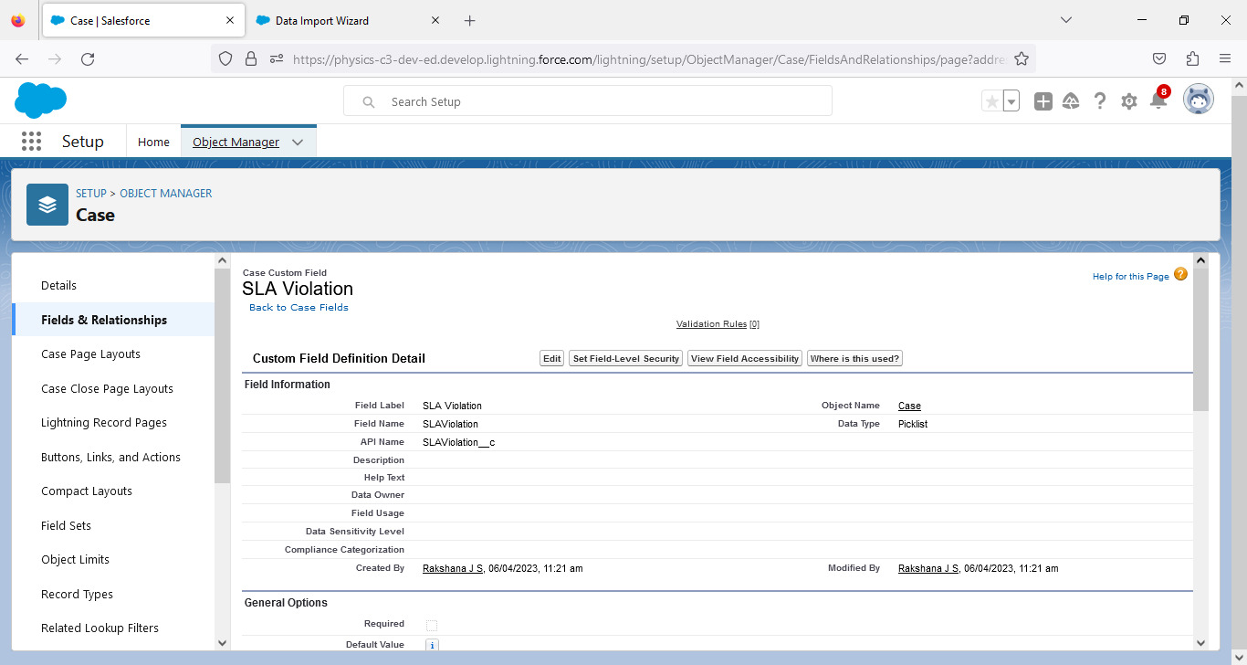

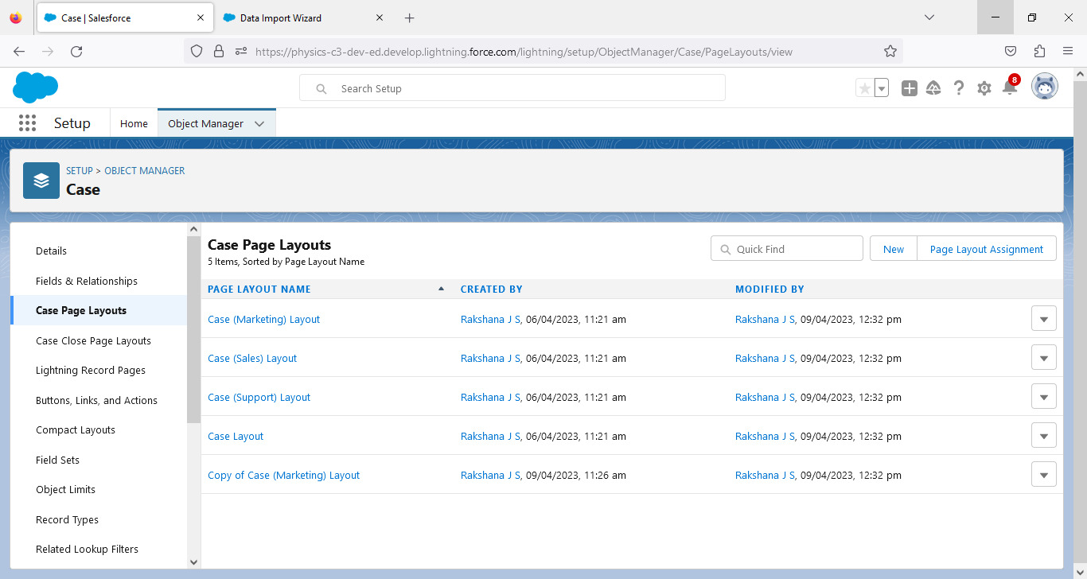

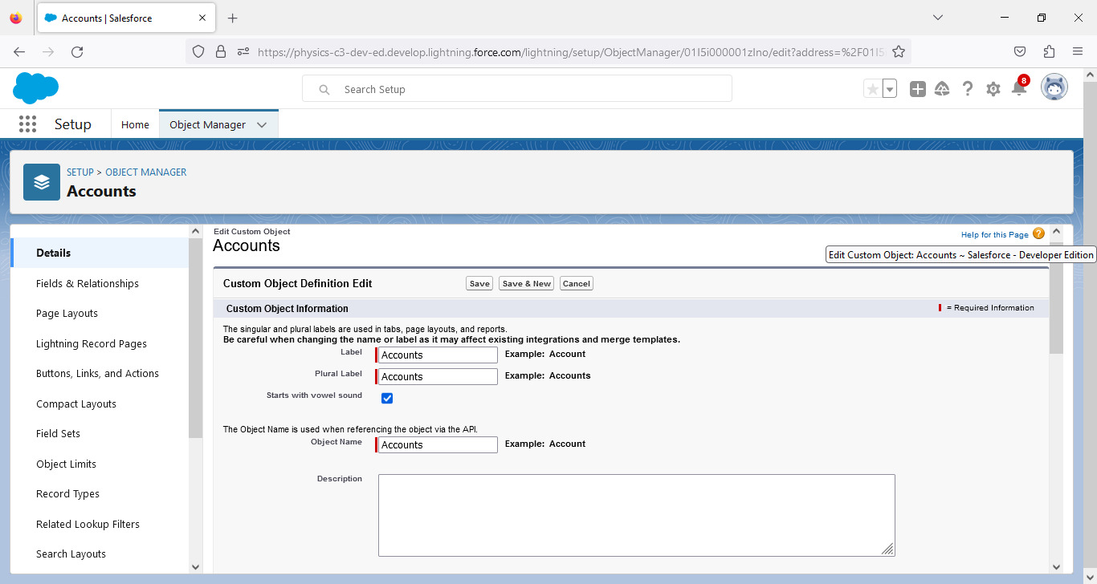

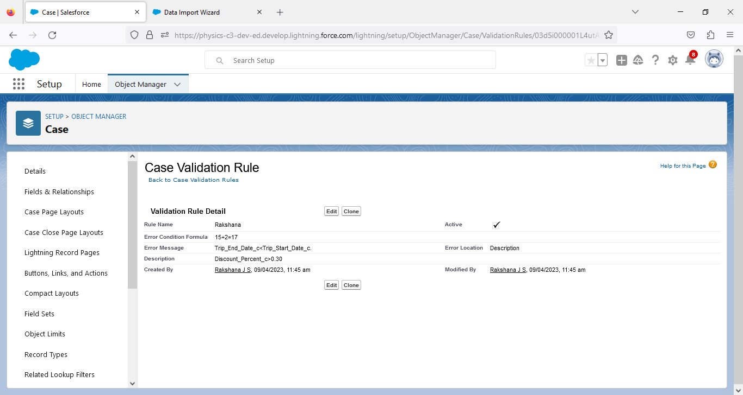

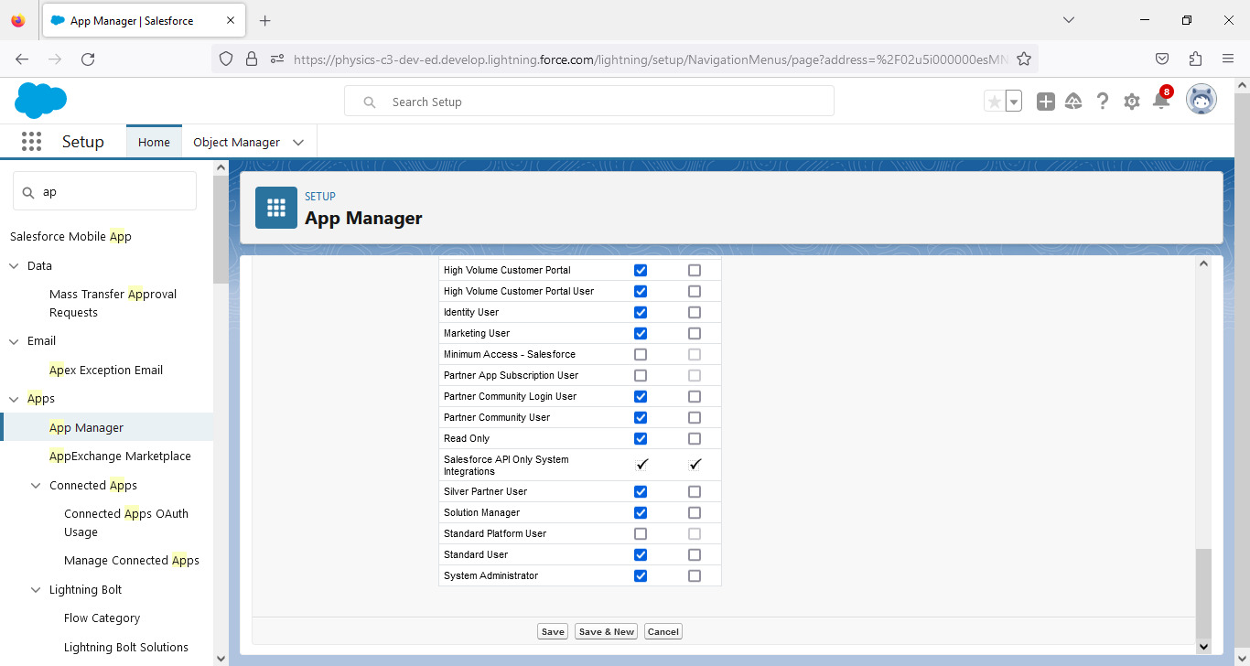

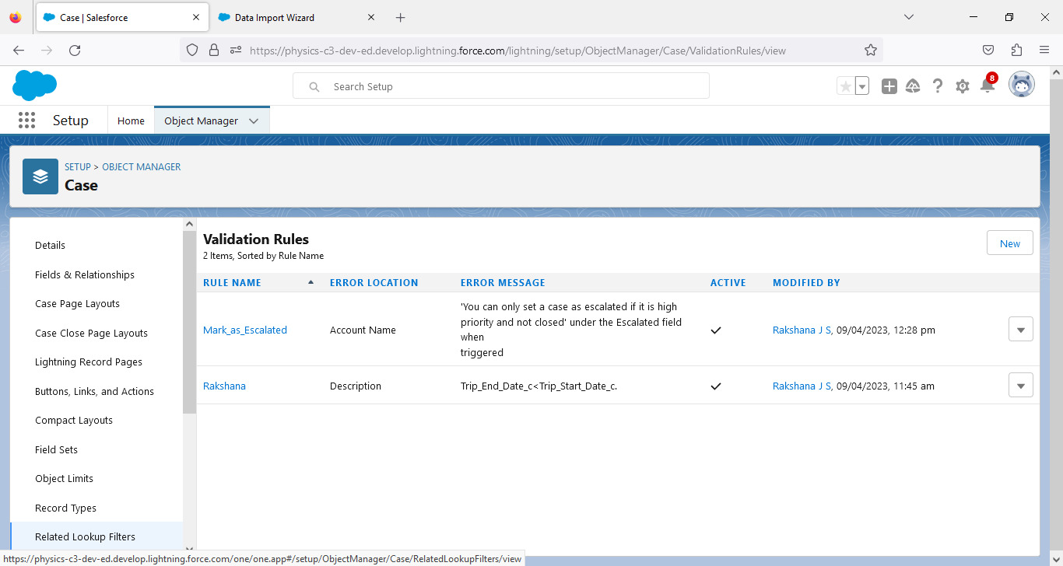

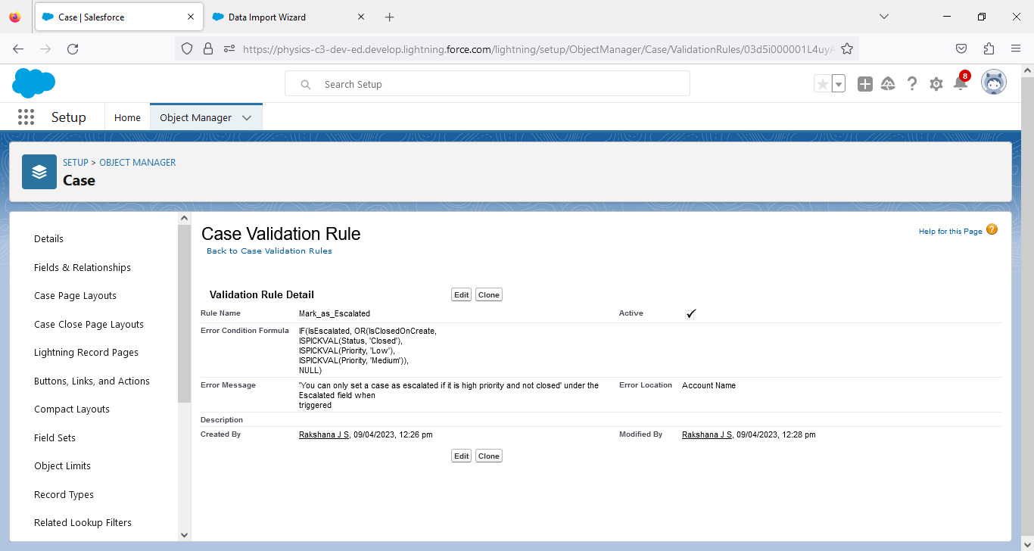

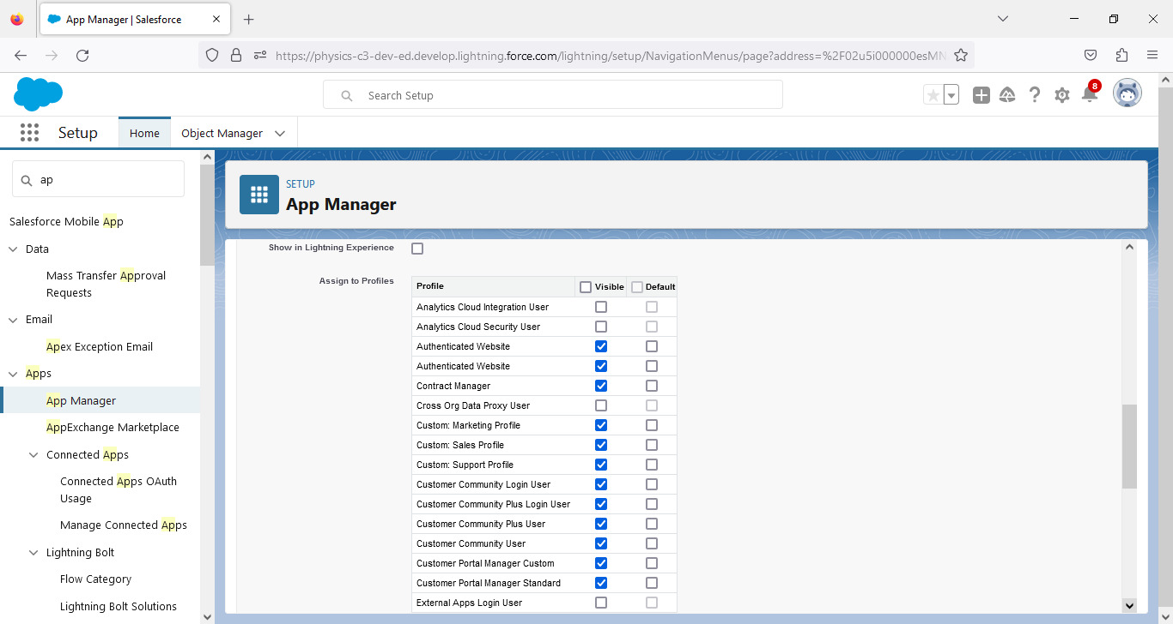

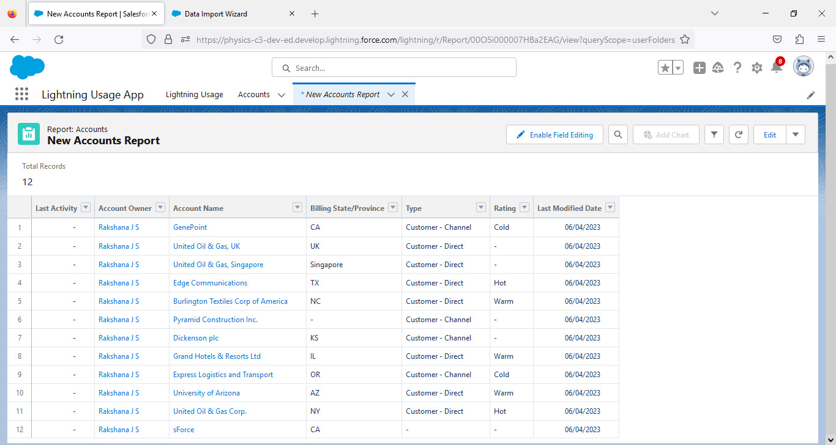

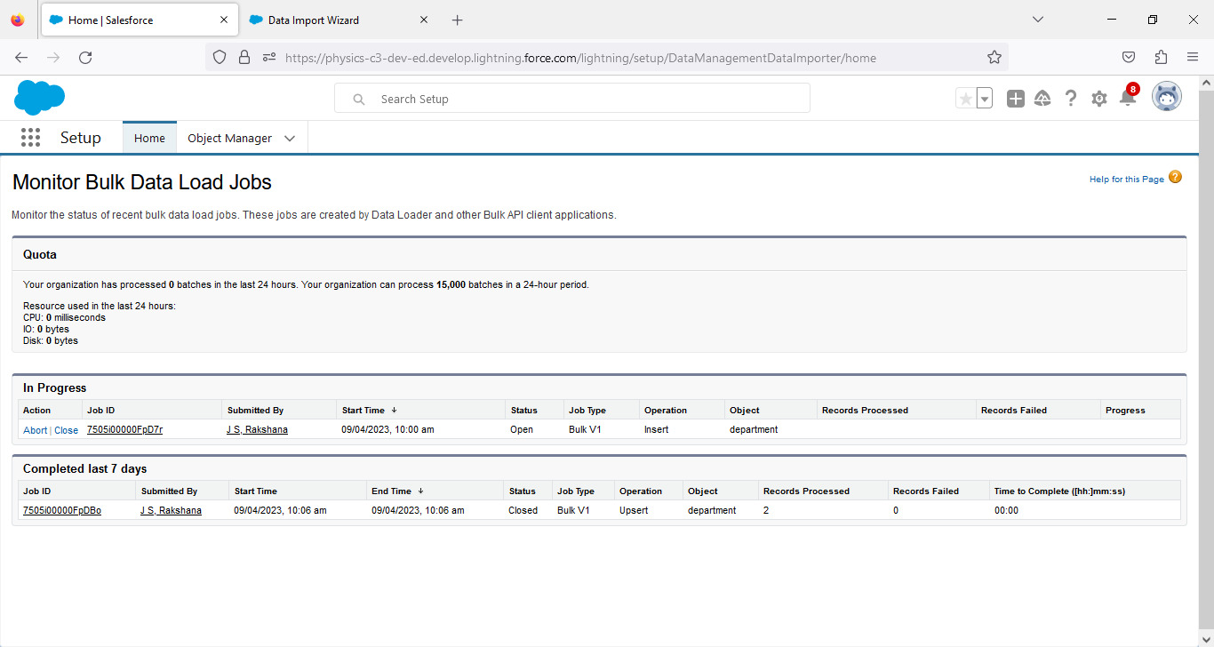

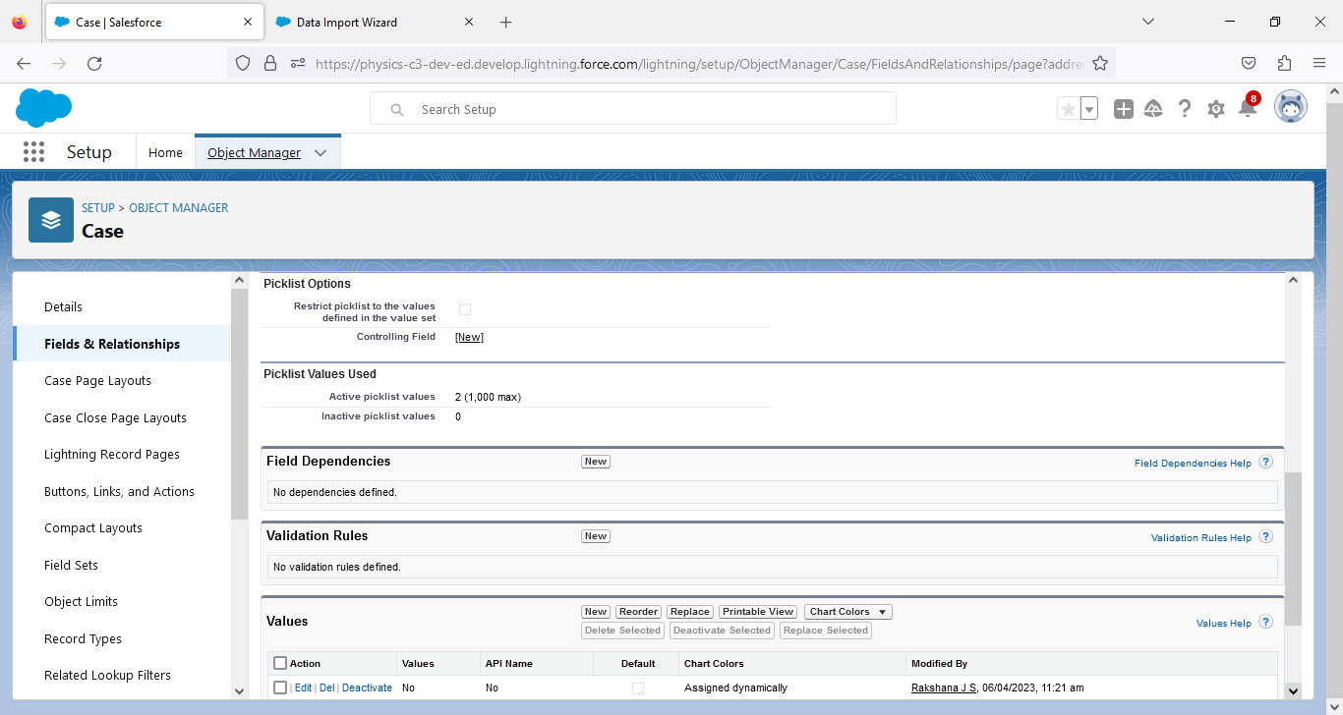

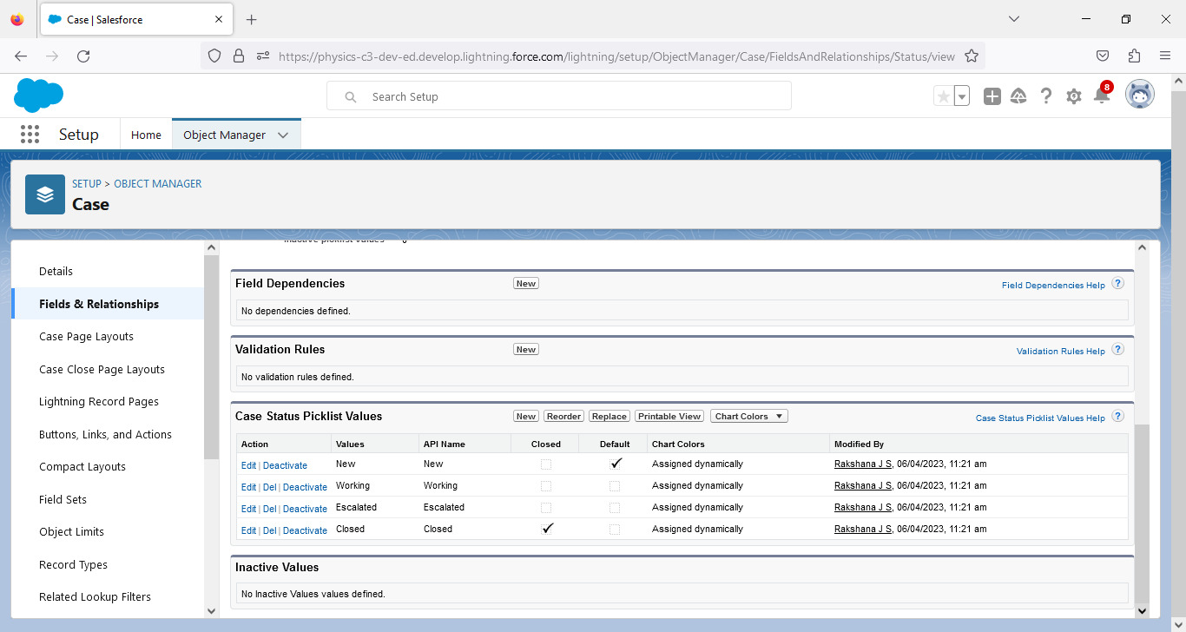

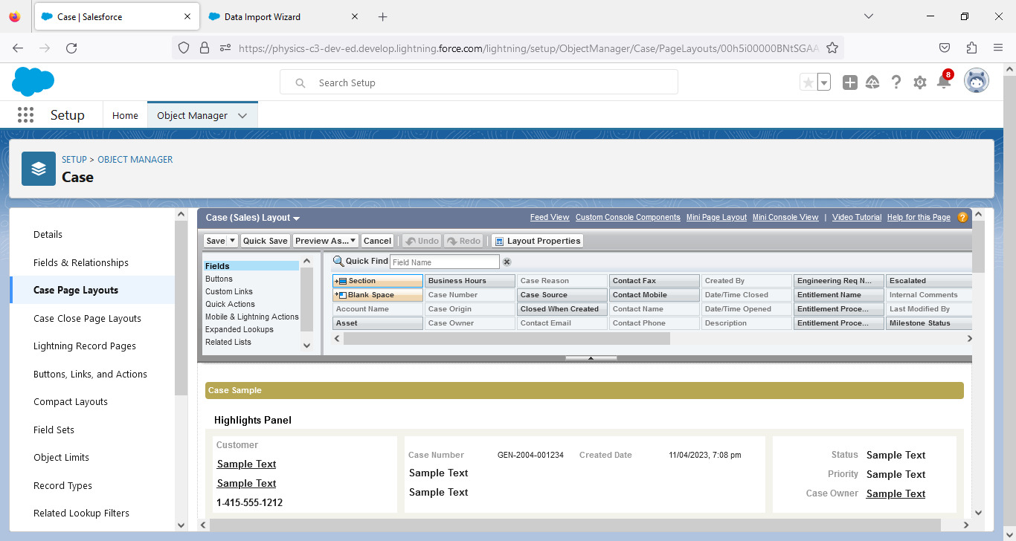

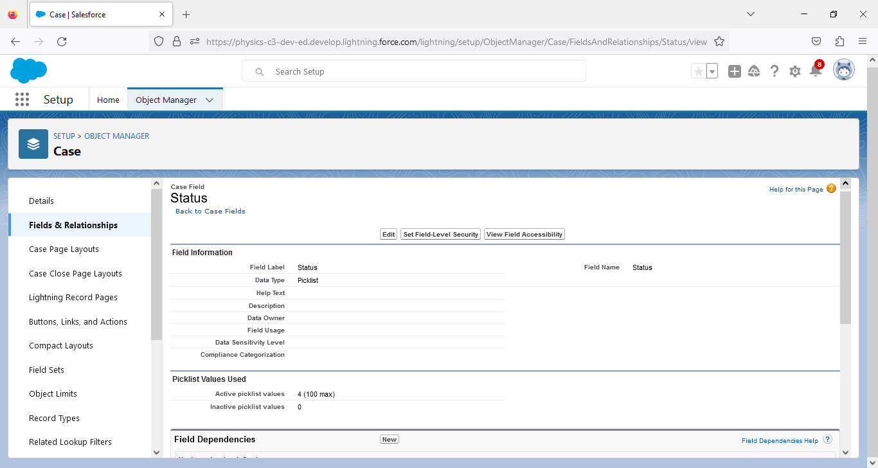

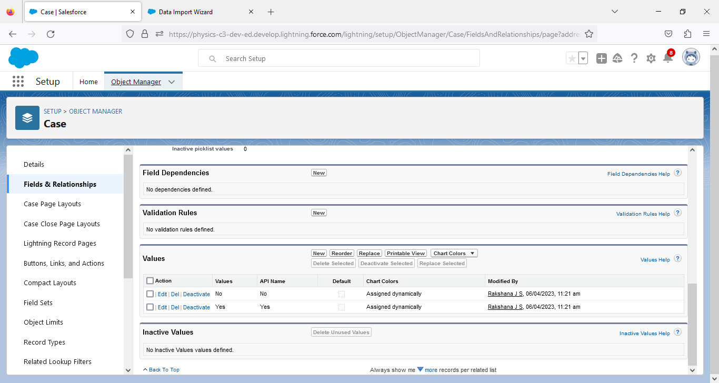

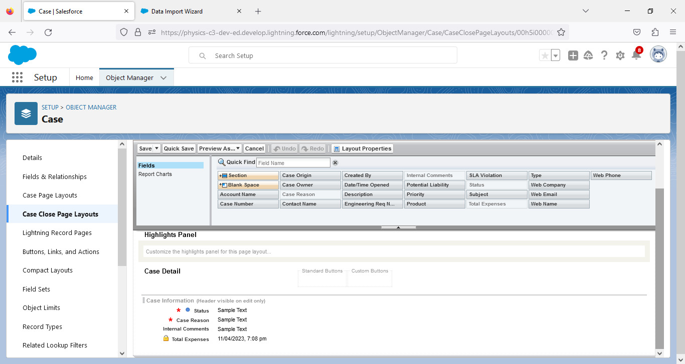

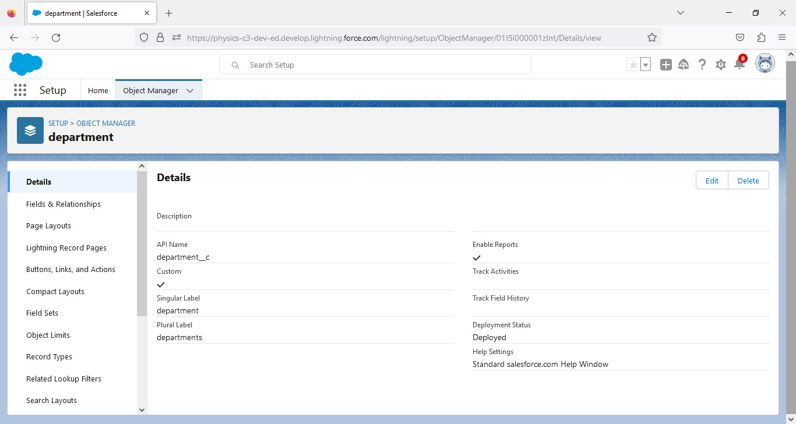

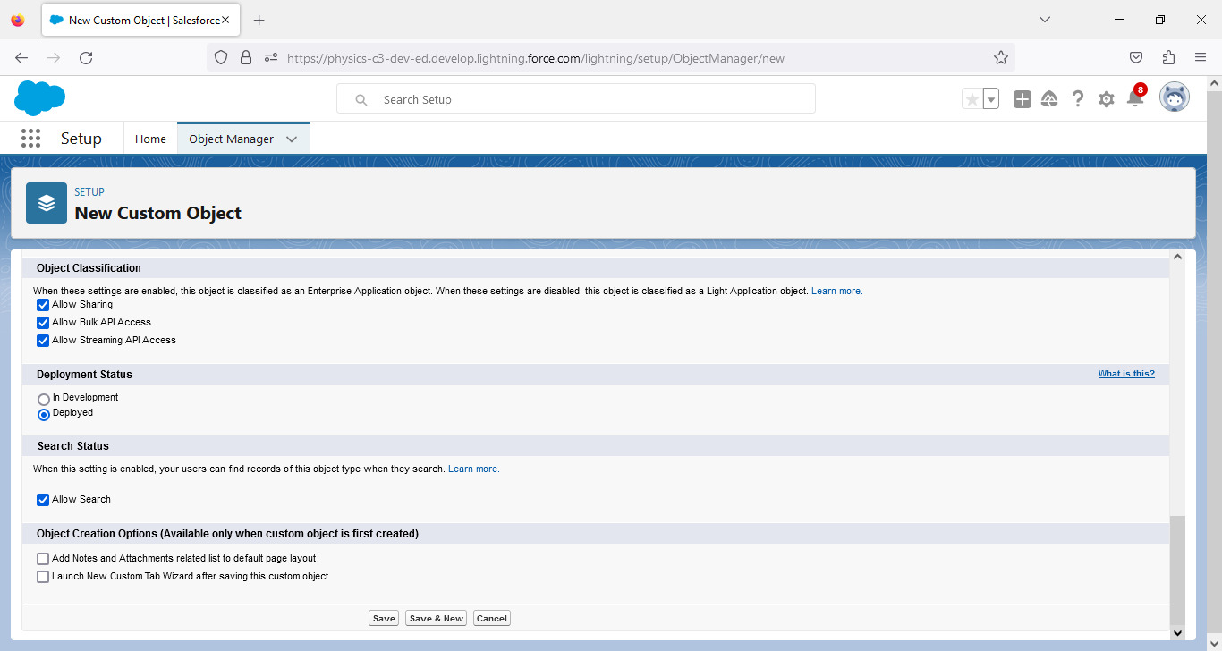

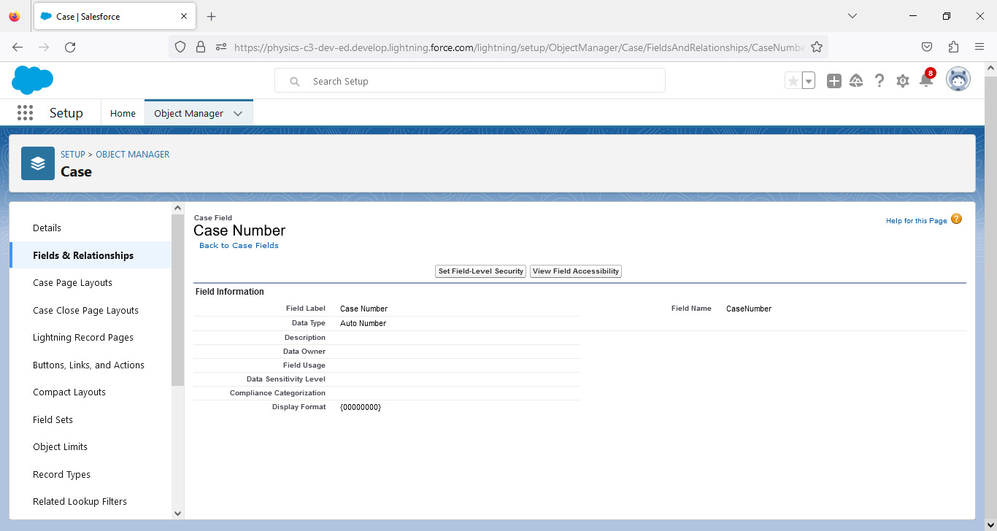



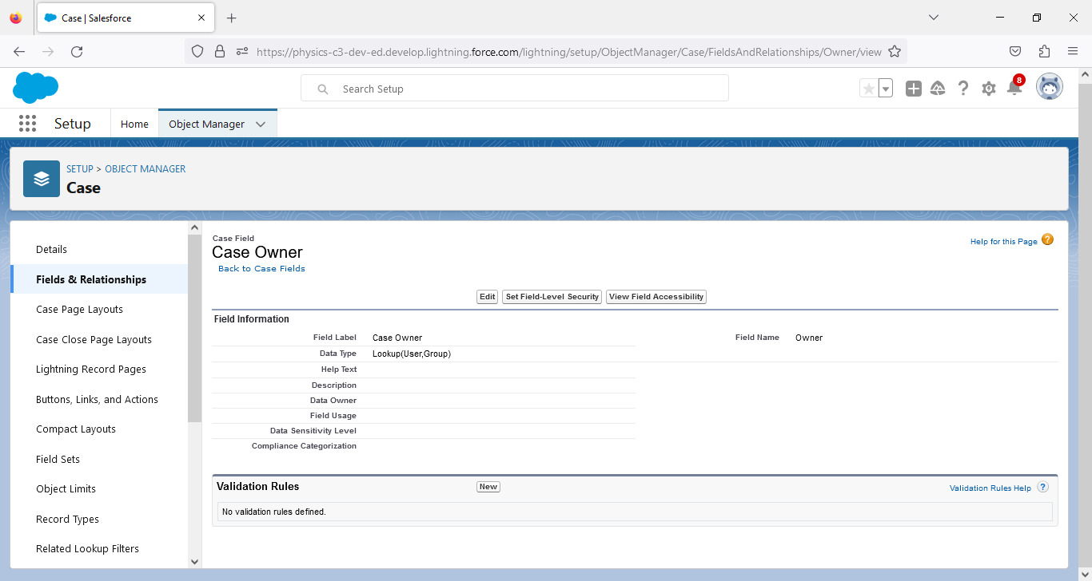

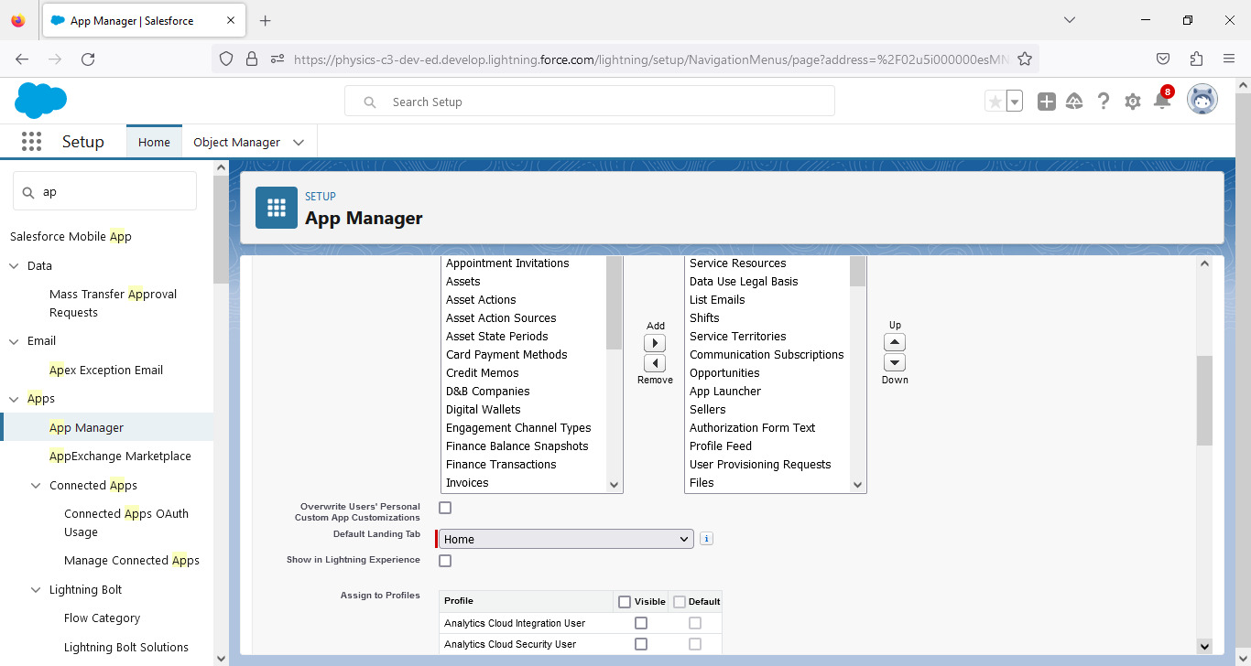

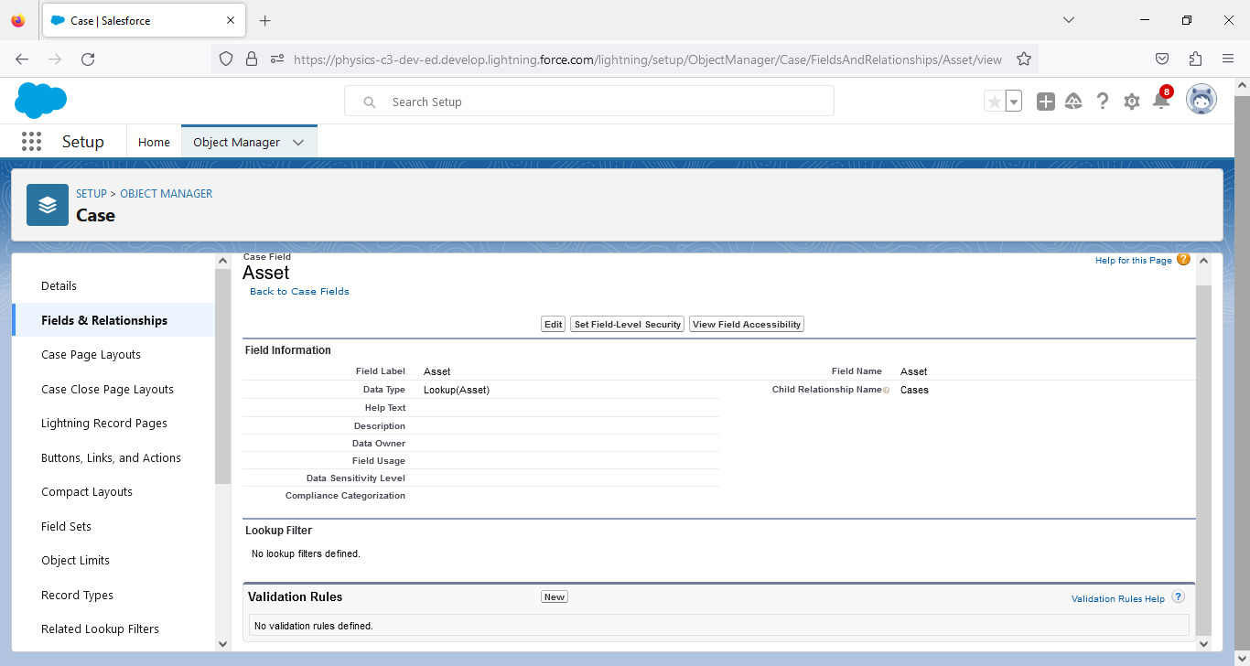

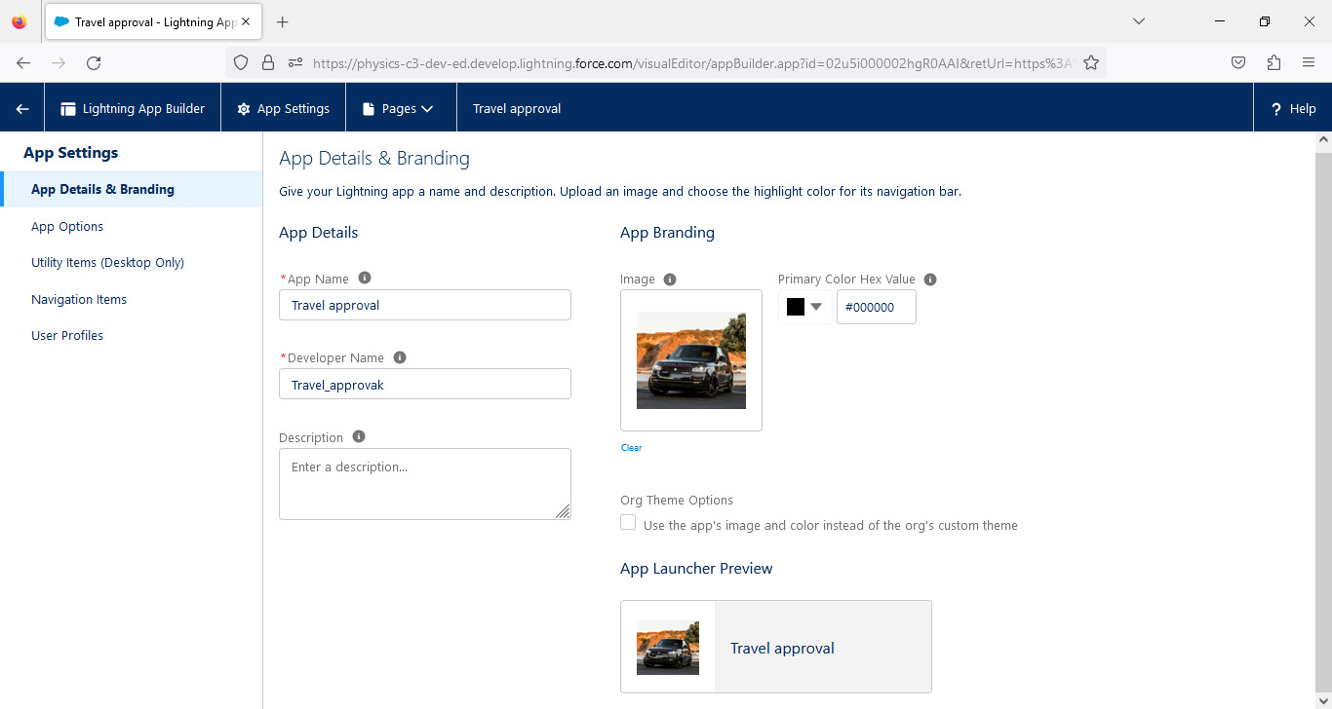

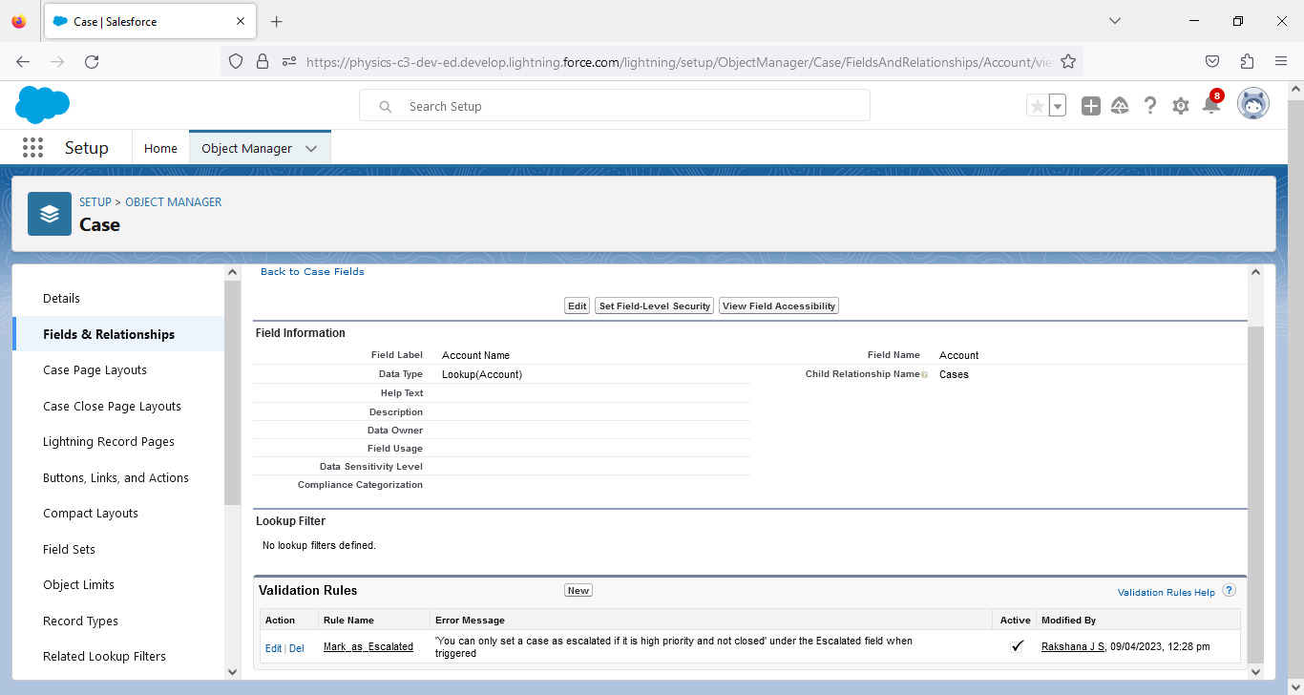

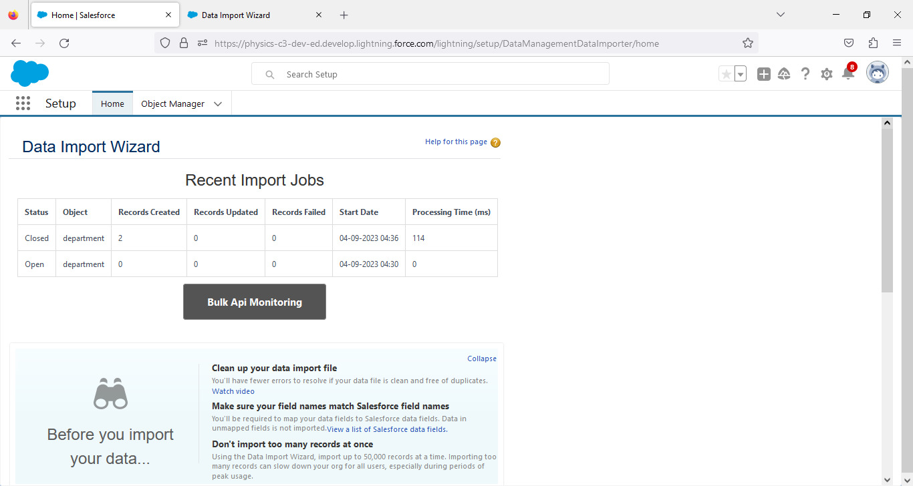

# 4.Trailhead Profile Public UR

# Team Lead trailblazer.me/id/rakj1

# Team Member 1 trailblazer.me/id/sssineka

# Team Member 2 trailblazer.me/id/sangavi

# Team Member 3 trailblazer.me/id/mary

# 5.Advantages & Disadvantages

# Advantage:Improved accuracy of important approval data.

# 

# Disadvantage: The biggest short coming of salesforce solution is simply their complexity.

# 6.Applications

# This will help executives the monitor the expected travel cost. This application can be used by the browser and available to the mobile power apps application.

# 7.Conclusion

# This study answers the call by previous researchers for future research to focus on emergent transaction channels.

# 8.Future Scope

# 1.There is a massive oppourtunity in travel application.

# 2.There is also a lot of unique challenges ahead that must be addressed.